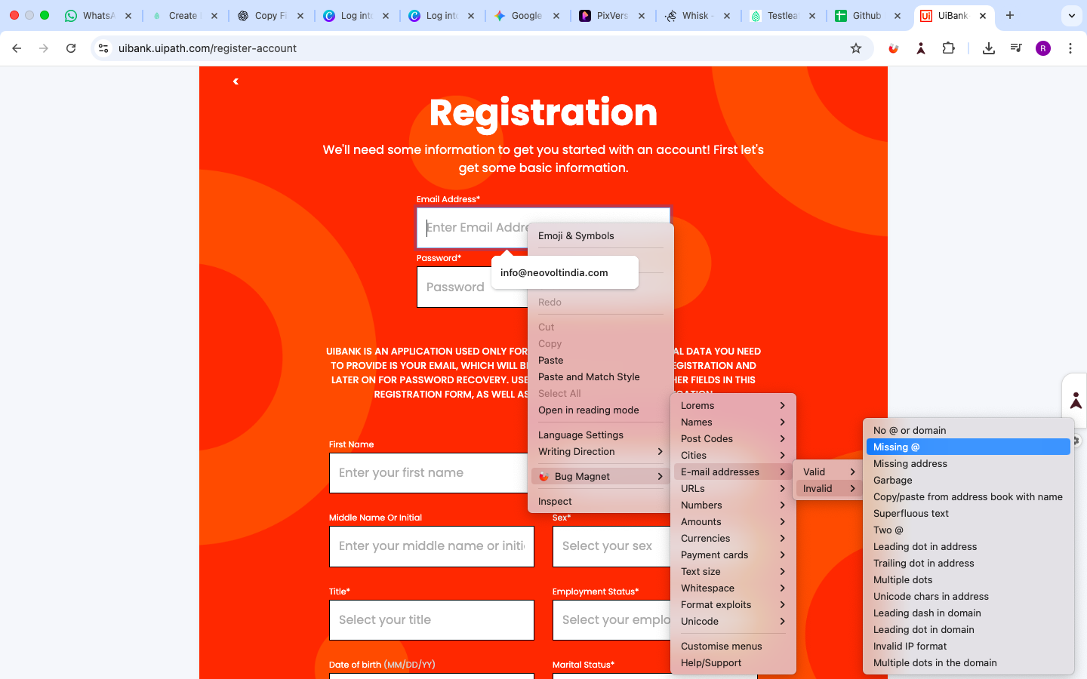
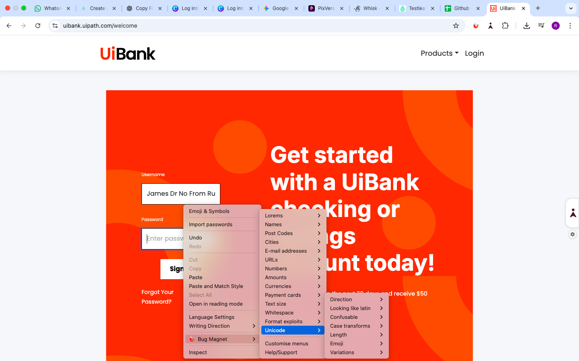

Observations
Below fields does not allow the Bug magnet, because those field already has dropdown, So user should select the drop-down
- Sex*
- Title*
- Employment Status*
- Marital Status*
- Number of Dependents
User needs to choose the count
- 0 (no dependents)
- 1
- 2
- 3
- 4
- 5

